2.3.2 Teachers use ICT-enabled tools including online resources for effective teaching and learning:
Links on College Website:

http://202.164.36.142:84/moodle/login/index.php
https://www.kmvjalandhar.ac.in/sitepages/free-online-resources/
https://www.kmvjalandhar.ac.in/sitepages/e-contents/
https://www.kmvjalandhar.ac.in/sitepages/misc-resources/

- 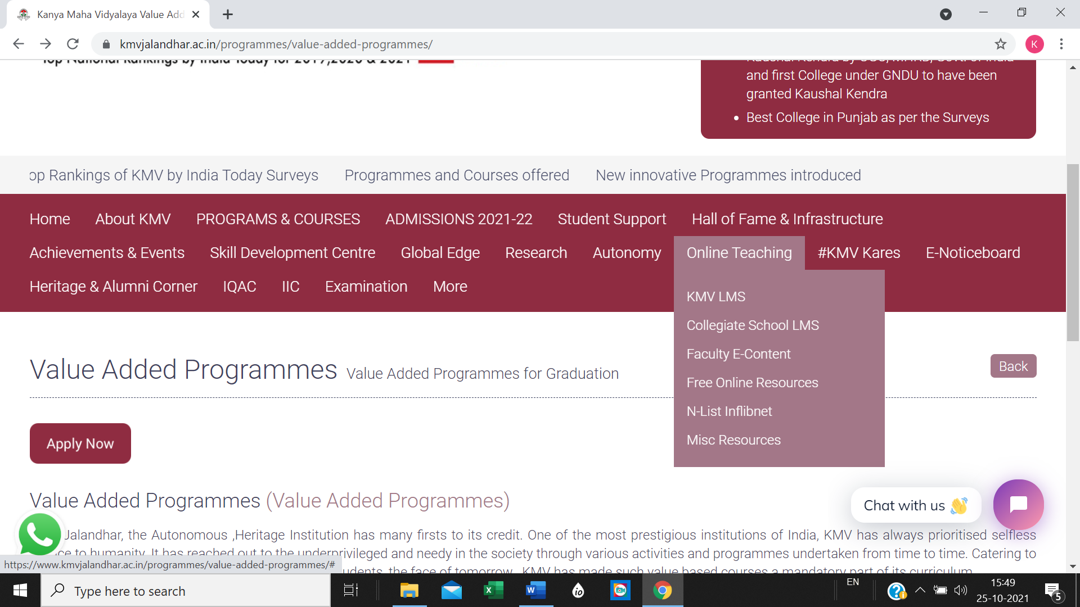

- 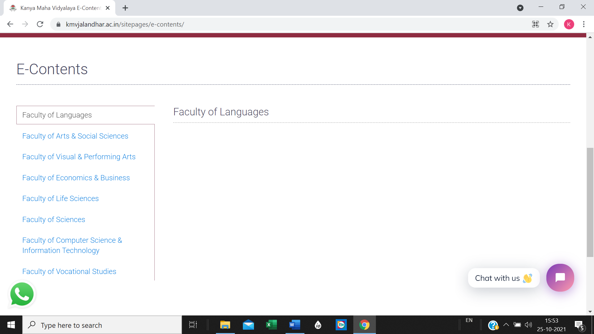
- 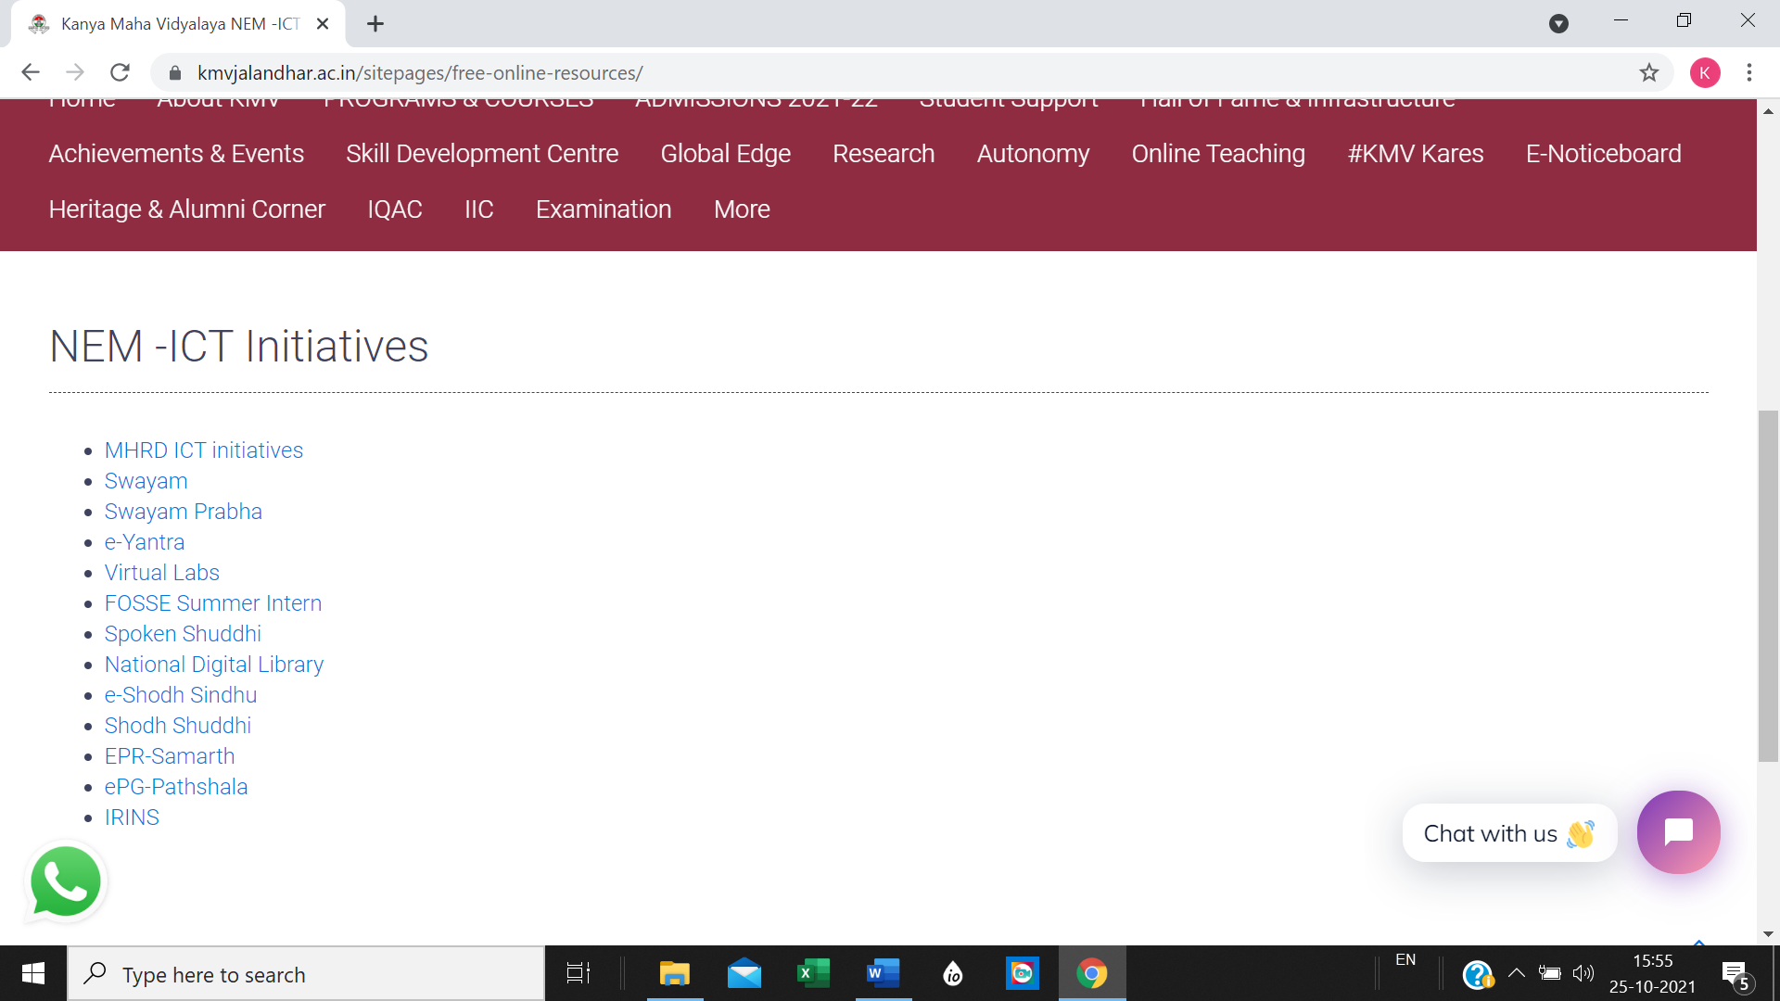

- 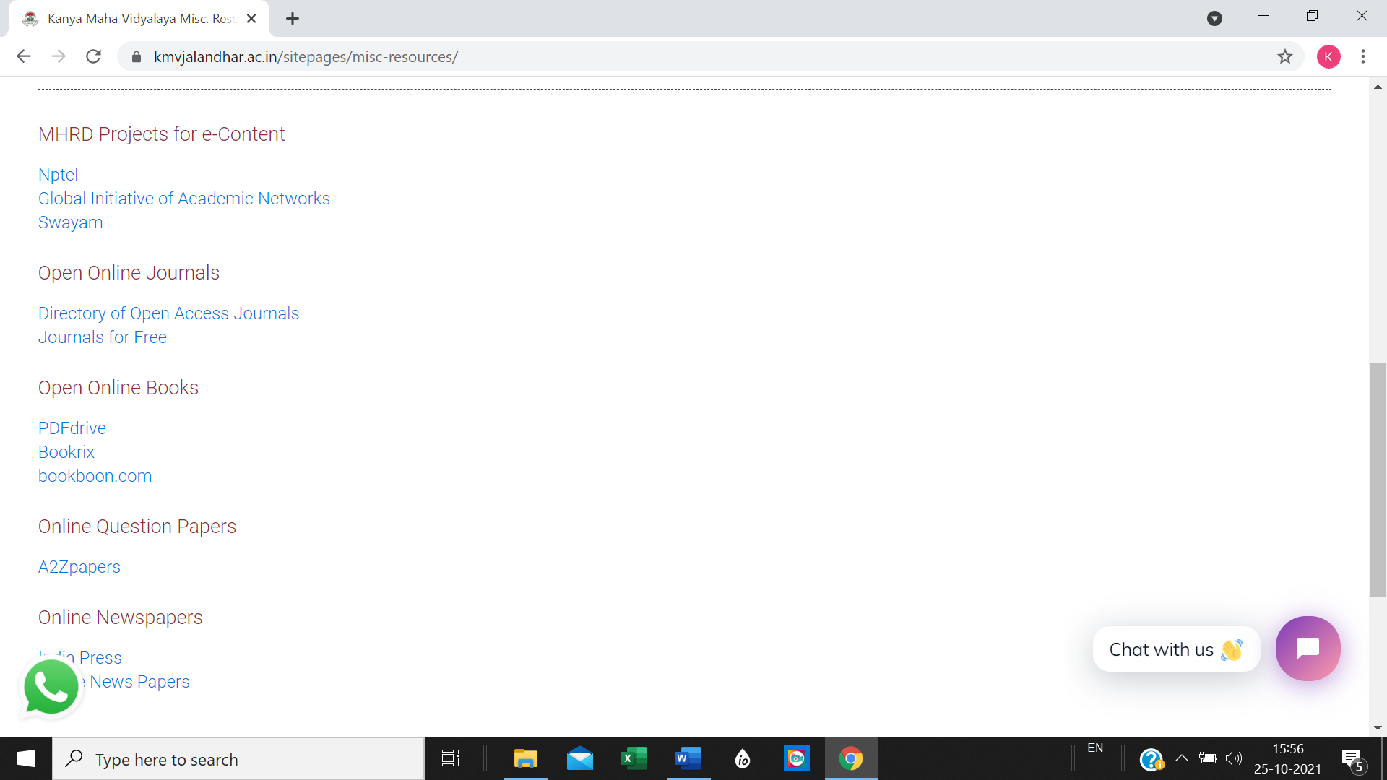

Digital library

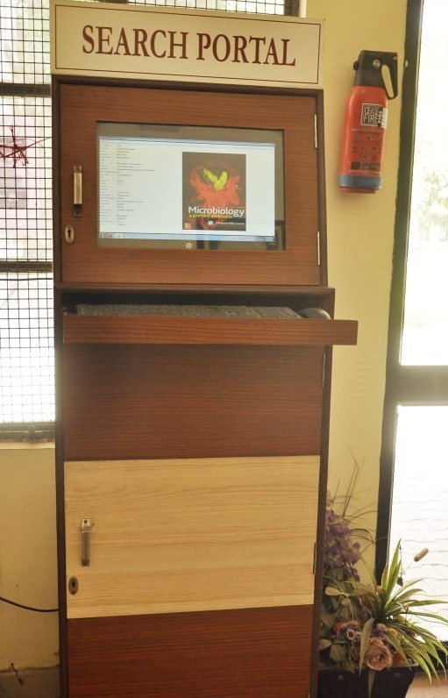
Resources

